Name:Adeena Yasin
Reg:8-FMS/BSBIN/F21
Assignment :3

DASHBOARD:

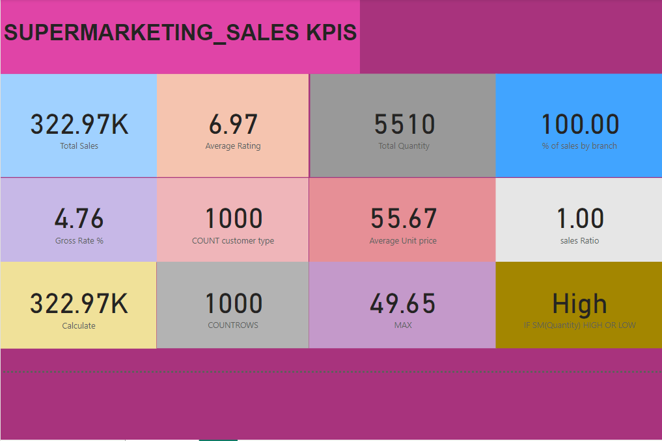

1. Total Sales (322.97K):
- What it means: The total revenue generated from all sales within the analyzed time period. This is a key measure of the overall financial performance of the supermarket.
- Significance: Helps to evaluate the volume of business being conducted and the total monetary value generated.

2. Average Rating (6.97):
- What it means: The average customer satisfaction rating collected from feedback or reviews. This metric is typically on a scale (e.g., 1 to 10).
- Significance: Indicates how well the supermarket meets customer expectations. A higher rating means better satisfaction.

3. Total Quantity (5510):
- What it means: The total number of individual items sold over the analyzed period.
- Significance: Measures the physical volume of sales, which complements financial sales data to provide a holistic view of performance.

4. % of Sales by Branch (100.00):
- What it means: The proportion of total sales that a specific branch contributes. In this case, it’s 100%, suggesting the data reflects one branch only.
- Significance: If data from multiple branches were included, this would compare branch performances, identifying top-performing locations.

5. Gross Rate % (4.76):
- What it means: Gross profit margin expressed as a percentage of sales.
- Significance: Indicates how much profit is earned from sales before deducting operating expenses. Higher percentages mean better profitability.

6. COUNT Customer Type (1000):
- What it means: The total count of unique customer types or classifications, such as Regular, VIP, or new customers.
- Significance: Provides insights into the diversity of the customer base and helps tailor strategies for different groups.

7. Average Unit Price (55.67):
- What it means: The average price of items sold.
- Significance: Useful for analyzing pricing strategy and understanding the overall product mix.

8. Sales Ratio (1.00):
- What it means: A comparison metric that could represent the ratio of actual sales to a benchmark or target.
- Significance: Indicates whether sales targets are being met. A value of 1.00 means the target is exactly achieved.

9. Calculate (322.97K):
- What it means: Likely a duplicated measure of total sales but derived using a calculation formula for validation or testing purposes.
- Significance: Ensures consistency and accuracy in the representation of sales data.

10. COUNTROWS (1000):
- What it means: The total number of rows (or records) in the dataset, typically representing the number of transactions.
- Significance: Indicates the dataset size and transaction volume, which is useful for understanding the scale of operations.

11. MAX (49.65):
- What it means: The maximum value recorded for a specific measure in the dataset. It might represent:
  - The highest transaction value
  - The peak quantity sold in a single sale
  - The highest unit price
- Significance: Identifies standout performance or extreme values in the data.

12. High (IF SM(Quantity) HIGH OR LOW):
- What it means: A conditional measure assessing whether sales quantities are classified as “High” or “Low” based on predefined thresholds.
  - Example: If the total quantity exceeds a specific value, it’s labeled “High.”
- Significance: Helps quickly assess whether performance is within the expected range or surpassing benchmarks.

